Lab Sheet 06  
IT2120 - Probability and Statistics  
  
  
Exercise  
  
1. An IT company claims that their newly developed learning platform improves student performance in online tests. According to previous data, 85% of students who used the platform passed their online tests. A batch of 50 students is selected at random who have completed the course using this platform. Let X denote the number of students who passed the test out of 50 students.

i. What is the distribution of X?

X∼Binomial(n=50,p=0.85)  
  
ii. What is the probability that at least 47 students passed the test?  
  
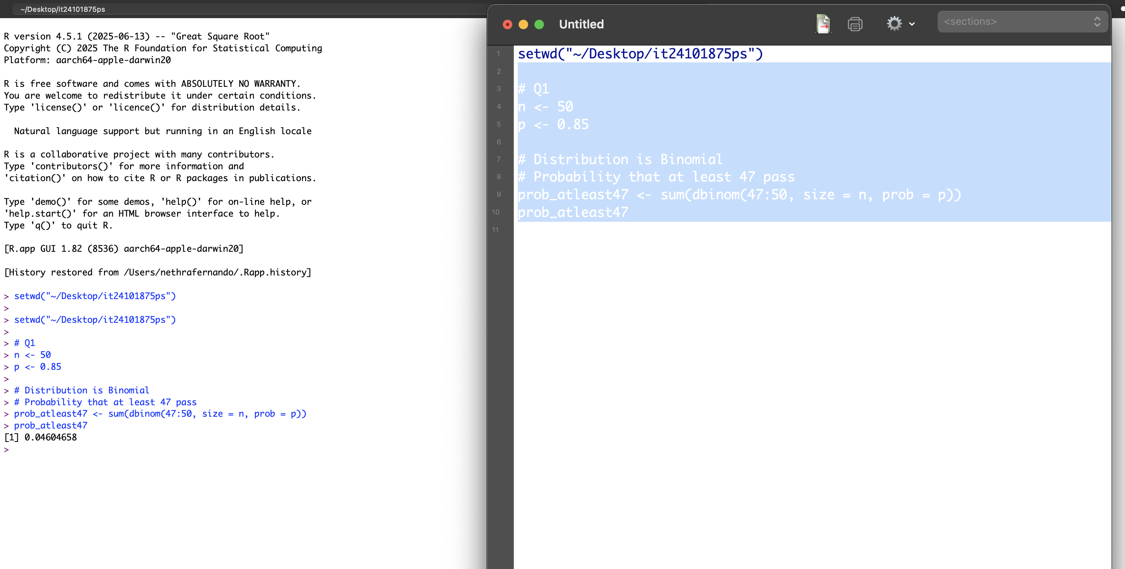

2. A call center receives an average of 12 customer calls per hour.  
  
i. What is the random variable (X) for the problem?  
  
X= number of calls received per hour  
  
ii. What is the distribution of X?  
  
X∼Poisson(λ=12)  
  
(iii) Probability of exactly 15 calls  
